# BUSINESS INTELLIGENCE

Business Intelligence (BI) customizes Data and Business Analytics and combines it with Data tools and visualizations for analysing data and presenting meaningful information that helps modern-day businesses and organisations to make informed and data-driven decisions.

Initially, BI used to be the work of just IT professionals, who would supply the whole organisation with the reports for decision-making, however now it is used at every stage of management by the managers (primarily due to the development in data science sphere and the rise of self- service BI tools).

**<b>Ways in which BI can help organisations make smart, data- driven decisions:</b>**

* Tracking performance
* Analysing Key Performance Indicators (KPI)
* Analysing the market share and consumer behaviour
* Optimizing business operations using historical data

## Business Intelligence Tools

Business intelligence tools are nothing but software that are used to analyse trends and extract insights out of the data in order to make tactical and strategic business decisions.

There are many Business Intelligence tools like SAS BI, MicroStrategy, Datapine, Domo, etc that help in carrying out the necessary tasks but two of the most powerful and widely used tools in Business Intelligence on which this blog is also dedicated are Power BI and Tableau.

**<b>Power BI</b>**

Power BI provides a brief summary of the data in the form of reports and dashboards while connecting with every data source across different. It makes data assessment, sharing scalable dashboards, embedded visualizations, interactive reports and various another feature which we will see further in the blog. It is amazing at importing visualizations with easy-to-use and user-friendly interfaces like Excel, etc. Power BI is simple for using that provides a full overview of your business performance.

**<b>Tableau</b>**

While there are numerous intuitive business intelligence tools, Tableau uses data discovery and its interpretation for all types of the business user. It is sometimes quoted as the most user-friendly data science tool available. Being simple to handle, any user without much of a stretch can perform reading or writing data related tasks along with analysing key data insights, while creating visualizations and innovative reports, and finally sharing insights throughout the enterprise with help of dashboards and stories. Tableau is good at connecting to any data source with a drag-and-drop interface that is easy-to-use and makes transferring data simple. However, unlike Power BI it is weak at combining with different data sources for analysis.

# INSIGHTS

As we have always said, hands-on real-time experience on analytics software are any day better than the theoretical concepts and is also our core strength, so to compare how the visualisations would look in Power BI and Tableau we took a same dataset and created a dashboard. We undertook a project under the supervision of our esteemed alumnus, <u>Mr. Vikrant Sharma</u> (Analyst, InMobi) and <u>Mr. Shoury Anand</u>(IIM Lucknow, PGP’22). This included a study on COVID-19 scenario where we took 5 datasets which contained data for number of COVID cases worldwide and in India. Also, to study what impact the current pandemic has on the indices we took time series data for S&P Global, FTSE 100 and Dow Jones along with Gold and Crude Oil prices starting from 1st January 2020 to 31st July 2020. To study how GDP has fared in the past years, we took Real GDP for 180 countries for past 13 years. Not surprisingly, the visualizations said for itself all the data which we collected and wanted to concluded our results. Finally, both the dashboards looked pretty amazing and gave us a hard time to choose one over another. So the question in on our readers which visualisation did they find better!

**<b>Tableau Dashboard</b>**

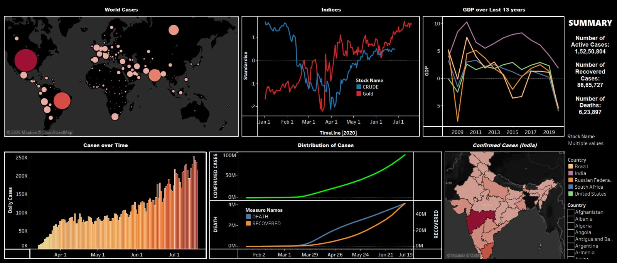

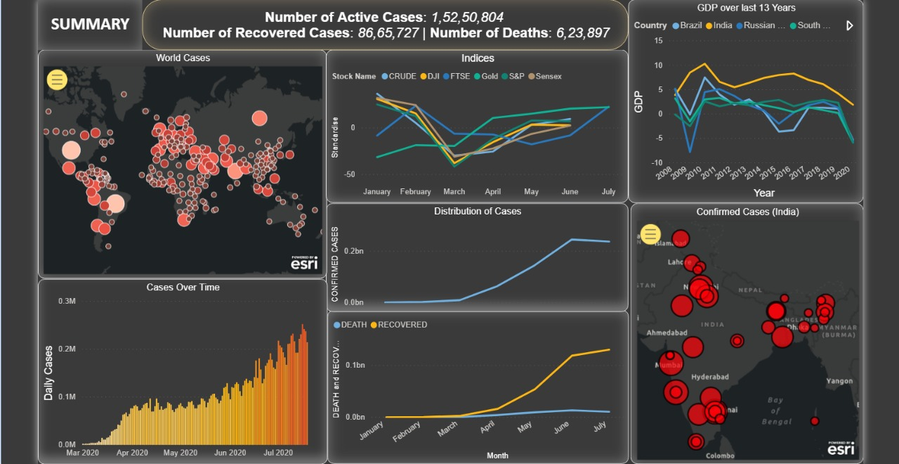

**<b>Power BI Dashboard</b>**

We have conducted a survey of sample size of 100 to gather and access the opinion of college students on Business Intelligence tools namely Power BI and Tableau.

The respondents had to answer various questions; like on what parameters would they favour one software from the other, rating these softwares on User- friendliness and attractiveness, their personal opinions/ experiences among others.

Most of the students replied on the same lines and the results matched our findings/ expectations. Tableau was found to be the favourable of the two.

<b>Some of the opinions:</b>

<i>“The Power BI Student Version has a lot of limitations and thus though it is capable to a large extent, cannot be used to its full capacity. Tableau has some limited features as compared to Power BI w.r.t graph styles, colour available, etc. Overall, Both the tools are very powerful for Data Viz”

"I feel that use of visualizations created in Tableau should be restricted to Tableau itself. Any presentation that requires only and only visualizations with little to none supporting text can be presented through Tableau's story mode. For PowerPoint presentations, I like to connect excel sheets with it for charts, as it makes it easy for me to change the formatting of the chart within PowerPoint and any change in figures can also be speedily done.

And about dashboards in presentations, I don't think that is a good choice because the number of visualizations in a dashboard might distract an audience, and it is difficult to demonstrate its dynamic features on a presentation.

I have had a better experience working with Power BI over tableau due to its user-friendly nature and a relatively easier visualisation capability.</i>

**<b>Result of the survey were as follows:</b>**

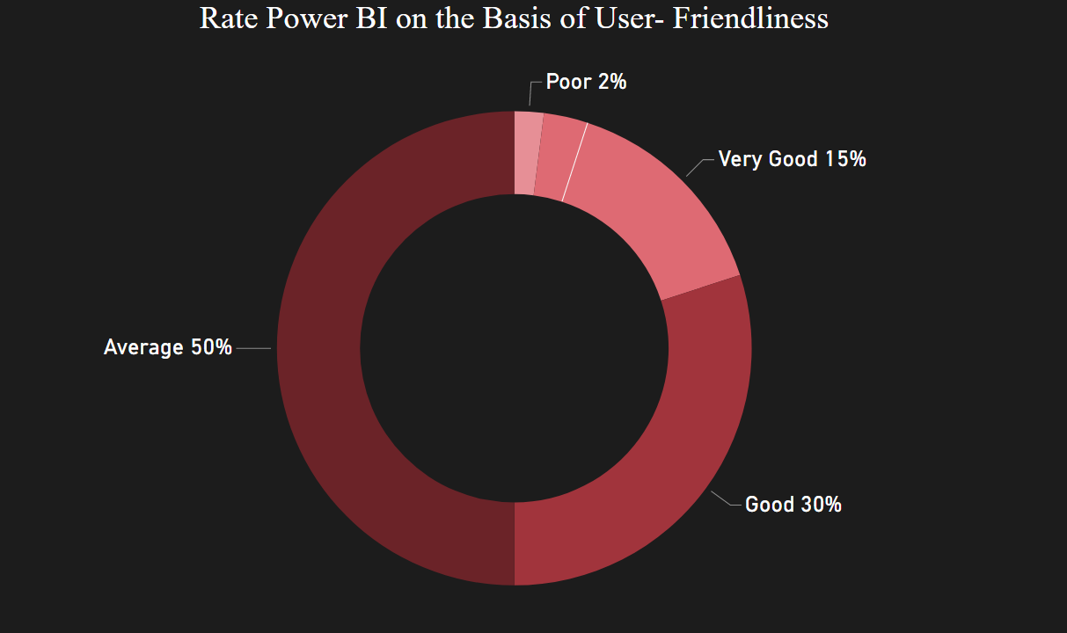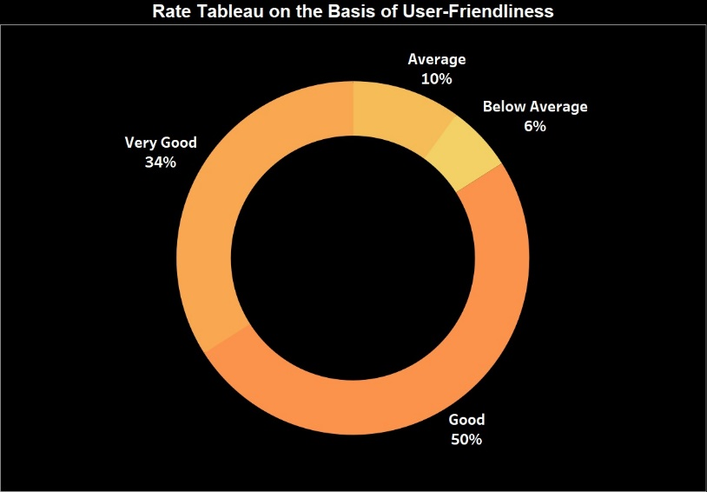

# BUSINESS INTELLIGENCE TOOLS FROM A STUDENTS’ PERSPECTIVE

Microsoft’s Power BI is a suite of data visualization and business analytic tools. It offers tools to easily analyse, transform and visualize data pipelines, including the ability to build reusable models. The software enables users to integrate their apps, to deliver reports along with real-time dashboards.

Tableau is a visualization tool that helps businesses transform their data into insights that can lead to action. The tool makes it easy to connect data in almost any format from almost any source. Interactive dashboard with visual analytics can be created with simple dragging and dropping, and data transformed in graphs, maps, charts, and other visualizations.

Data Visualizations tools are necessary when it comes to creating visual representation of analytics and sharing the insights with other.

And as Management students, we faced difficulty initially in choosing the best tool for making reports and dashboards, because both Power BI and Tableau were terrific and had a lot to offer. So, to make life simpler and easier, we’ll be comparing these two on a range of parameters:

1. **<b>Cost</b>**

Tableau is expensive than Power BI when it comes to buy the complete version which usually is bought by the businesses and working professionals. Tableau’s annual price ranges around $1000 while Power BI’s annual price ranges around $100. Even though there is a great price difference in the full version, however if we compare only the free version Tableau has an upper hand. This is because many useful features were not included in Power BI’s free desktop version and this certainly impaired us during this project. We also had to face many hassles when it came to editing the shared files.

1. **<b>Data Analysis</b>**

Power BI should be the choice if someone wants to have an in- depth analysis of the data. It offers DAX (Data Analysis Expressions) which is a delight to work with. It is designed to work with tables and relational database, creating meaningful relationships between various data sources.

Tableau has in-built features like data blending and drill-down, which one can use to determine the variations, data patterns and for further data analysis.

1. **<b>Data Visualization</b>**

There is no one best tool when it comes to Data Visualization as both Power BI and Tableau has some really powerful visuals to offer. While talking about simplicity, surely Tableau creates fascinating dashboards through simple drag- and- drop, and complex calculations can also be made with the help of simple line of codes. It offers various types of visualizations such as Heat maps, Treemaps, Scatter Plots etc. One can also create ‘Word clouds’ and ‘Bubble charts’ in Tableau.

On the other hand, Power BI has loads of visualisations which help in depth analysis. Power BI boasts of a wide variety of visualizations, such as R script visuals and Python visuals as well. These visuals can be created in Power BI Desktop and then published online.

1. **<b>Performance</b>**

The Clock Rate in Power BI is faster than that in Tableau, it loads data sets faster than the latter, plus it saves the files in a compressed manner and takes lower disk space. One can also publish their Power BI Desktop reports online and thus can have an easy access.

1. **<b>User community</b>**

Both these tools offer great customer support, in terms of services and learning material. However, Tableau may have an upper edge in community support due to its huge user base and awareness in general.

1. **<b>User Interface</b>**

Tableau has an edge over Power BI when it comes to the user interface. It has an intuitive user interface along with versatile features. Its Tool Tip is more efficient than Power BI’s and provides elaborate details.

Power BI’s user interface is no less than that of Tableau’s but it can be a little intimidating for a novice.

After comparing the 2 tools on various parameters and from our personal experience, we felt that Tableau is the better of the two when it comes to creating Dashboards and visualizations.

# Conclusion:

Tableau remains the choice of BI Tool for students from non-technical background like us. However, the professional reports and perfect visualisations by Power BI would certainly add a feather in your cap in terms of both skillset and employability.

